2025
SILVER CAMP
PARENT HANDBOOK

TABLE OF CONTENTS

WELCOME LETTER ___________________________________3

CAMP DATES AND TIMES______________________________4

MEET OUR TEAM_____________________________________5

CAMP PACKING LIST______________________________6

DROP OFF/PICK UP PROCEDURES_____________________7-9

HEALTH & SAFETY ________________________________10-11

CAMP PROGRAM__________________________________12-13

CAMPER POLICIES & PROCEDURES______________14-17

WELCOME LETTER

Dear Parents/Guardians,

Summer Camp is in full motion, and our Silver Camp Team is excited to see all our campers' smiling faces. Our team is trying to make your experience as easy as possible, so we are providing you with an additional information booklet for parents, that will help you answer all your questions.

Silver Camp is now based at the northern end of our campus at the Children’s Pavilion. (Diagonal to the Gift shop, where you will also see our playground)

ALL CAMPERS will gather at the Children’s Pavilion DRIVE THRU Drop Off/Pick up Traffic Circle and be further directed to their group’s home base.

Child Watch (Age 3-4 Half-Day Program) home base will be inside of the Children’s Pavilion which includes a private playground behind the Pavilion.
Wee Woozles (Age 5) home base will be in the tent next to the playground at the Children’s Pavilion.
Woozles (Age 6-7) home base is inside of the Children’s Pavilion which also includes the front covered patio.
Chippies (Age 8-9) home base is the tent behind the Children’s Pavilion next to the Nature Center.
Ravens (Age 10-12) home base is in the basement of Morse Hall.
Teen Camp (Age 13-14) home base is in the basement of Morse Hall.

The Camp Registrar will be located in the Administrative Building but will always be accessible.

Sincerely,
Jason Waddell
Youth and Teen Camp Coordinator

CAMP DATES AND TIMES

SUMMER CAMP DATES
Session 1 June 23-June 27
Session 2 June 30 –July 4
Session 3 July 7-July 11
Session 4 July 14-July 18
Session 5 July 21-July 25
Session 6 July 28-August 1
Session 7 August 4- August 8
Session 8 August 11-August 15

SUMMER OFFICE HOURS
Monday through Friday
8:00am-3:30pm
*There will be staff available during Breakfast Club and Post Camp, but management staff may not be directly available outside of office hours.

CAMP REGISTRAR
Keri DuRoss
Phone number 518 543-8833 ext 312
Email: silvercamp@silverbay.org

MEET OUR TEAM
We are excited to introduce you to the members of our team. Our mission is to partner with you and make certain that our campers have the best possible experience!

YEAR-ROUND TEAM
EDUCATION DIRECTOR– Jackie Palandrani
YOUTH AND TEEN/CAMP COORDINATOR- Jason Waddell
SILVER CAMP SUPERVISOR– Kathleen Leonard
CAMP REGISTRAR– Keri DuRoss

SUMMER TEAM
SILVER CAMP TEAM LEADER – Madalynn Hubbard
SILVER CAMP TEAM LEADER – Chloe Adzigian
TEEN CAMP TEAM LEADER – Drew Gelbaugh
CHILD WATCH TEAM LEADER- Kay Downer
HEALTH OFFICER- Jocelyn Longacre
CAMP COUNSELORS:
Camille Downer
Alexandra Fisher
Chloe Freeman
Emma Geils
Ari Greenberg
Emma Lastowski
Charlie Moses
Ellie Mott
Carrie Schneider
Teddy Schutze
Nicole Schiaffini Ruiz
Hannah Scotland
Nate Testa
Caleb Ward
Brianna Watkins

CAMP PACKING LIST
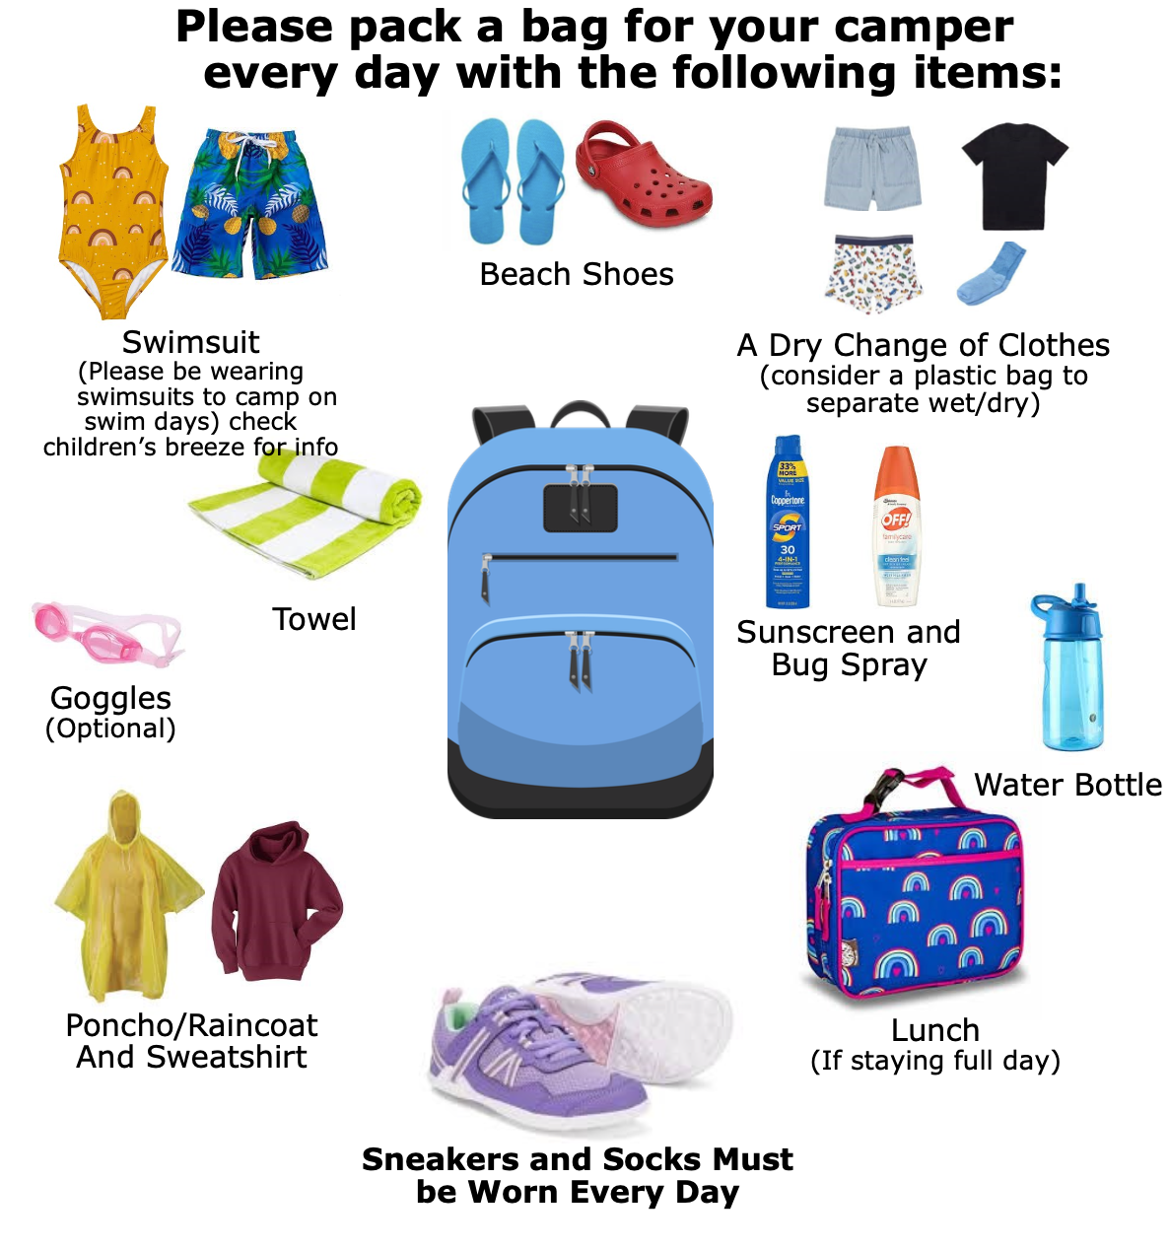(If campers don’t bring sneakers they may not be able to participate in certain activities)
Don’t forget to LABEL all items with your
camper’s FULL NAME!
*The Children’s Breeze will be sent out weekly with the camp program schedule, so that parents can pack accordingly
DROP OFF/ PICK UP PROCEDURES

Drop-Off is from 8:15am to 8:30am @ The Children’s Pavilion Drive Thru Circle

Pick-Up is from 3:15pm to 3:30pm @ The Children’s Pavilion Drive Thru Circle

IF YOU SIGNED UP FOR THE BELOW SESSIONS:
Breakfast Club- Drop off from 6:30am –8:00am @ The Children’s Pavilion
Post Camp- Pick Up is from 3:30pm – 5:30pm @ The Children's Pavilion
*Breakfast Club and Post Camp allow drop off/pick up throughout the duration of the session.

DROP-OFF
Please do not arrive to drop off campers before 8:15AM, there is not a place for you to wait or park and staff will not yet be available to supervise children.
At 8:15AM Drop Off begins at the Children’s Pavilion.
Staff will be directing traffic at the stone gate. Please note that this is not a parking area at this time, but a drop off and pick up loop only.
It is essential to keep vehicles moving through the loop as there is not enough space to accommodate all cars. Our staff will be there to greet you at your car, sign in your camper(s), and direct them to their camp group.
Please have your camper(s) unbuckle themselves and hop out or if they require assistance, temporarily park in the labeled pull off zone and help them out as efficiently as possible. Our staff will not be able to buckle or unbuckle your camper(s). Please make sure they have their camp bag ready.
*If you need to speak to our camp Registrar, Camp Director, or Health Officer, simply park in the pull off zone at the end of the loop. You are also welcome to park elsewhere on campus and walk your camper directly to their group to assist them with the transition or have the opportunity to talk with their counselors directly.
*If walking to camp, we recommend using the pedestrian path behind Morse Hall, instead of walking through the traffic loop to approach the Sign In team. We apologize for the limited vehicle space and appreciate your help in making sure all families can get through the traffic loop without holding up traffic on the public Silver Bay Rd.

PICK-UP
Similar to drop off, you will be directed by our staff and asked to stay in your car as you go through the loop to pick up your camper(s) at
the Children’s Pavilion parking lot. Staff will communicate by radio to guide campers from their home bases to your vehicle. Children will only be permitted to leave with those on their authorized pick up list and staff will need to verify the identity of any unrecognized adult.
ANYONE PICKING UP A CAMPER WILL BE ASKED TO
SHOW PROPER PHOTO IDENTIFICATION

SAFETY INFORMATION
• Administrative staff will be on the driveway to direct you.
• Please stay in your car if possible and follow the direction of our staff.
• Please be prepared to have camper(s) enter and exit on the passenger side of the vehicle.
• Please do not use your cell phone in the drop off line.
• DRIVE SLOWLY! campers may be crossing the road!

LATE ARRIVIALS EARLY PICKUP

LATE ARRIVAL To ensure the safety of our campers who are arriving late to camp, parents should walk their camper to lower Morse (Camp Office). If no one is in lower Morse, go to the front desk in the Inn. We will then arrange for a staff member to escort your camper to their group.

EARLY PICK-UP To ensure the safety of our campers getting picked up from camp, campers who are leaving early must be picked up from the camp office in lower Morse. If parents/guardians are aware that they will be picking up a camper before the standard time, they should alert camp staff or give them a note with the pick up time at drop off. If an early pick up is unplanned and the time is not known in advance, parents/guardians should go to the Camp Office and ask them to radio a camp team leader who will then collect the camper from their current location on campus as well as their belongings and bring them to the front desk. If no one is available in the Camp Office, go to the front desk at the Inn and have them radio us.

BREAKFAST CLUB
Breakfast club is only available for registered campers ages 5-15 who have signed up for this session. Campers attending this session will need to be dropped off anytime between 6:30 am- 7:30am at the Children’s Pavilion.
At 7:30am Campers will be walked over to the William Boyd Center Dining Hall for breakfast. At 8:15 a.m. campers will be brought to their home base for the start of camp. If you are dropping off a Breakfast Club camper after 7:30am go to the Front Desk at the Inn and have them radio Children’s Program. They will then redirect you to the dining hall where a counselor will be waiting to sign your camper in.

PLEASE REMEMBER WE ARE NOT RESPONSIBLE FOR LOST OR STOLEN ITEMS.

POST CAMP
Post Camp is only available for registered campers ages 5-15 who have signed up for this session. Post Camp will be held at the Children's Pavilion from 3:30pm- 5:30pm. Children may be picked up at any time within this window. Campers are encouraged to bring a snack for this session as we do not have snacks available. Campers will have access to the Playground and various other activities like crafting. We will remain at the Children’s Pavilion throughout the duration of Post Camp.
*Please use the Children’s Pavilion Parking lot loop for pick up from Post Camp.

PLEASE REMEMBER WE ARE NOT RESPONSIBLE FOR LOST OR STOLEN ITEMS.

HEALTH AND SAFTEY

At Silver Bay, we take the health and safety of our campers and staff very seriously. Our Health Center staff are trained professionals. Additionally, we ask that you partner with us in keeping every camper healthy. Please do not send your camper to camp if they are not well enough to participate in camp activities or could make others ill. All campers must be fever free for 24 hours, without fever medicine, before they can return to camp. If your child has flu like symptoms, they will not be able to attend.

We will contact you if:
• Your camper becomes ill with a fever and/or vomiting/ GI symptoms.
• Your camper has a significant bump, bruise or cut.
• Your camper has any head related injury.
• Your camper visits the health center multiple times in one day. If we can't
reach you, we will call additional emergency contacts as provided on your registration forms.

All minor injuries such as bumps, bruises, cuts and scrapes that may occur during the camp day will be treated by the Camp Health Officer/Nurse. They will also store and administer medications needed by campers.

PRESCRIPTION MEDICATIONS
All medications to be taken or held at camp must be accompanied by a note from a parent/guardian and a prescription note from the camper's Doctor. The note must include your camper’s name, name of the medication, dosage, time to be given, permission to administer, and your signature. All medications need to be given directly to the Health Officer at drop-off. Medications must be in the original prescription bottle with the correct label. All medications will be kept in the Health Office.

NON-PRESCRIPTION MEDICATIONS
Over-the-counter medications can only be administered with the proper documentation on file: if both a parent/guardian and the camper’s Doctor have signed off on said medication. State law mandates that any medication, over-the-counter or prescribed, epi-pens, or inhalers, etc., will be administered by the camper themselves, our registered nurse, or someone certified to administer.

SUNSCREEN & BUGSPRAY
Please help campers apply sunscreen before arriving at camp. We ask that you send each child to camp with their own bottle of sunscreen (LABELED WITH THE CAMPER’S NAME). The same applies if you choose to use any form of insect repellant. Counselors will help remind campers to reapply during the day, but camp staff will not provide sunscreen or bug repellent to campers. *With a written parent note, a Camp Counselor can assist with the application of the Camper’s own sunscreen and/or bug repellent.

CAMP HEALTH FORMS
The Department of Health requires that all campers submit their medical forms prior to the beginning of camp. You can access your medical forms online through your Ultra Camp account. Health Forms must be current within the last twelve months. We MUST have all medical forms on file before the first day of camp for campers to attend camp.

EMERGENCY PROCEDURES
All camp staff are trained to respond to medical emergencies, fires, other building evacuations, lockdowns, and more. Fire drills happen at camp every Monday. In the event of a camper having a medical emergency or any other emergency affecting camp, parents/guardians will be notified as soon as possible. In the event of an emergency such as a fire alarm evacuation, parents/guardians are welcome to come be with their campers but may not sign any children out until all parties are accounted for and it is deemed safe to do so.

ABUSE PREVENTION
Silver Camp strives to meet the highest possible standards for child abuse prevention and reporting. Our team is trained to recognize red flags, follow strict policies for camper safety, and respond appropriately to protect all children. We ask that any concerns are immediately communicated to camp staff and/or reported to NY State using the hotlines found below:
Call NY Statewide Toll Free Telephone Number:
1-800-342-3720
If you are deaf or hard of hearing, call TDD/TTY at 1-800-638-5163 OR have your Video Relay System provider call 1-800-342-3720

CAMP PROGRAM

SILVER BAY YMCA MISSION STATEMENT
To cultivate relationships, strengthen communities and nurture spirit, mind and body for all.
SILVER BAY YMCA IMPACT STATEMENT
Because of Silver Bay YMCA, connections between people and family are stronger. People are more connected, respectful, and caring. They have the confidence to develop to their full potential and to positively impact the communities in which they work and live. As a result, communities are more dynamic, comprehensive, and varied. As stewards of Lake George, we inspire people to be stewards of the environment while they are visiting our magnificent campus and in their home communities.
CORE VALUES
Our core values of Caring, Honesty, Respect and Responsibility are integral
parts of both our philosophy and program. Campers and staff promote
these values daily with team building activities, catching campers "doing
something good" and discussions about what it means to be kind, confident
and respectful. While camp is an opportunity to work on swimming, sports
and arts, it's also an opportunity to learn about ways to become a better
person.

Silver Bay YMCA’s Silver Camp is designed to provide kids with opportunities to try new things, gain confidence, and build positive relationships with others. The Silver Camp experience provides a dynamic program in an environment which fosters growth and independence for every child. The relationships that children form with each other and with our staff provide the foundation for learning about themselves and others. At the heart of Silver Camp is our variety of amazing activities led by a talented group of staff. This is where the fun, engagement, friendships, learning, and camp memories begin.

ACTIVITIES

SCHEDULE
Individual group schedules will be emailed in the Children’s Breeze the week prior to each session. Visits to program areas such as Archery, Boathouse, High Ropes, Rock Wall, Nature Center, Beaches etc, are scheduled weekly for all age-appropriate groups. Please make sure that campers are dressed appropriately for scheduled activities, especially hikes. Counselors will also plan sports, games, and arts activities inspired by the weekly theme.

SWIMMING
Silver Camp’s swim program follows the guidelines of the American Red Cross Instructional Swim Program Levels 1 – 6.
Swimming is an integral part of our program with daily swim lessons scheduled for every age group. Groups also have additional free swim once a week with the possibility of extra swim times during hot weather. We ask for kids to wear their swimsuit to camp under their clothes on swim days and bring a dry set of clothes to change into after lessons.
Before getting in the water each summer, every camper is swim tested by Red Cross certified Water Safety Instructors who assign them to the appropriate swim lesson level and determine which swim zones they are permitted to enter. They will have the opportunity to test up regularly. To swim in deep water and go out to rafts, a camper must pass our deep water test and receive green swim bands. In order to swim in water up to chest line, a camper must pass our intermediate swim test and receive orange swim bands. Those designated non-swimmers will be given white swim bands and need to stay in the shallow water zone. Teen Campers will be swim tested but are not required to participate in Swim Lessons.

RAINY DAYS
Our camp runs rain or shine. It is helpful to send your camper to camp
prepared for both rainy day and regular day activities. We will maintain a
regular schedule with outdoor activities, including swimming, for as much of the day as possible. In the event of heavy rain or lightning during the day, we have sufficient indoor space to keep campers and staff safe and dry for
the duration of the storm. However, poor weather or air quality may result in a change from originally scheduled activities.

CAMPER POLICIES & PROCEDURES

BEHAVIOR EXPECTATIONS FOR CAMPERS
Campers should expect a fun and safe environment while at camp. We
know that there may be times when campers may not get along or agree
with one another. However, we expect that these disagreements will be
handled in a kind and respectful way. We want everyone at camp to feel
that they are in a safe environment where they are valued.

CAMPER RULES
- Stay with your group at all times!
  - Never wander off alone.
- Don’t go in the water without a counselor!
- Always come to camp prepared.
  - Wear shoes, bring bathing suit, water bottle, sunscreen, bug repellent, and lunch (if not purchased)
- Treat others how you want to be treated
- Use kind words, keep hands and feet to yourself
- Be respectful of others’ belongings!
  - Do not take anything that is not yours.
- Listen to counselors and instructors!
- Respect nature
  - Clean up after yourself, don’t pick up animals, sticks, rocks, and other parts of nature
- Do not bring toys or valuables to camp.
  - We are not responsible for lost/broken items
- No fighting or weapons at camp!

CONDUCT & DICIPLINARY POLICY
Silver Camp promotes learning, respect, and a safe environment. We have a strict no bullying policy. All participants and parents should read and familiarize themselves with the policy and procedures when registering for camp.

The following will not be permitted at camp:
• Inappropriate action/behavior: Abusive/Foul language/and or inappropriate gestures/actions directed toward participants, staff, or other persons.
• Harm to others: Physically assaulting another person, (participants, staff or other persons). Including striking, pushing, shoving, spitting, proximity intimidation and/or grabbing or attempt or threat to physically injure another person.
• Harm to self: Physically harming/injuring self or attempting or threatening to do so.
• Misuse/Damage of property: Improper care or misuse of items that belong to the camp or another person.
• Stealing-Removing property belonging to others or to camp without permission.
• Inappropriate touching of others or lewd behavior.

BULLYING
Bullying is when one or more people exclude, tease, taunt, gossip, hit or
put down another person with the intent to hurt. At Silver Camp, we have
a firm policy against all types of bullying. Our goal is for every camper at Silver Camp to feel welcome, and we work together to ensure that campers gain self-confidence, make new friends, and return home with great memories. Our staff are trained to recognize and intervene to stop bullying. Our camp leadership will do our best to communicate any incidents of concern to parents/guardians of any campers who may be involved in or on the receiving end of bullying behaviors. We also encourage families to partner with us in advocating for campers by sharing any concerns so that our team can support kids in healthy conflict resolution and ensure that everyone has the best possible time at camp.

PROGRESSIVE DISCIPLINE POLICY
If a participant’s behavior is disruptive, staff will redirect the camper and give a verbal warning identifying inappropriate behavior and consequences should the behavior continue. If the child continues to be disruptive, the following progressive discipline steps will be used to get a child back on track with the code of conduct policy.

1st infraction: If verbal redirection is ineffective and inappropriate behavior continues, a staff member will enact a minor and relevant consequence as outlined in the verbal warning. These consequences should be brief and age appropriate such as a brief time out apart from the group, temporarily sitting out of an activity, writing an apology, or assisting staff with an undesired task such as cleaning. The staff member will reiterate the desired behavior and consequences should the problem behavior continue.

2nd infraction: If inappropriate behaviors continue to occur or become more serious, the Camp Coordinator will be informed and will call the camper’s parents/guardians and notify them of the continued inappropriate behavior. If the Camp Coordinator considers the behavior sufficiently disruptive, they will ask the parent/guardian to discuss the following: Has this behavior been observed before? If so, what tends to cause this behavior? Is there a behavior management plan already in existence that effectively controls behavior? Does the parent have recommendations for managing this behavior so the program can be successful for all?
After the situation is assessed, the Camp Coordinator will work with the camp staff to develop a behavior management plan. The plan will then be signed by the participant and/or parent/guardian and shared with camp staff for consistent implementation.

3rd infraction: If disruptive behavior persists, a second meeting may be held with the participant, parent/guardian, camp staff and the Youth and Teen Director to discuss appropriate options; if these steps are unsuccessful, a participant may be suspended or expelled from camp. The participant may be asked to leave the program for the remainder of the day or for longer at the discretion of the Youth and Teen Director. In the event a child is suspended from the program for any period, the registration is non-
refundable. The Camp Coordinator will determine whether dismissal from camp is necessary. If dismissal is the decision, the parent/guardian will be informed, and it will become effective immediately.

Please note that these steps are used as guidelines. Exact responses to behaviors are situational and depend on the severity of the inappropriate behavior. Disciplinary decisions are at the discretion of the Camp Coordinator.

LOST & FOUND
Silver Bay and Silver Camp are not responsible for lost, stolen, or broken personal items. We highly recommend that valuables stay at home. Our counselors do work hard to ensure that camper belongings are properly cared for, but it is very common for children to lose track of items such as water bottles, towels, and clothing. Placing labels or writing your camper’s name on EVERY article of clothing will make it easier for us to return lost items.
Discuss care of personal belongings with your camper before camp. Younger campers, especially, need to be familiarized with their belongings. Campers at Silver Camp are encouraged to be independent and care for their personal belongings.
If you find something is missing, please check with your campers’ age group to look through the appropriate lost and found bin at the end of the day. If you still can’t locate the missing item, notify camp staff, giving any details that will help locate and identify the missing item. While we cannot guarantee success, we will do our best to return missing items to their owners.

ELECTRONICS & TECHNOLOGY
Silver Camp strives to be an electronics-free environment. We ask that campers keep electronics, cell phones, and other internet accessible devices at home or keep them safely away in backpacks. These items are not permitted during camp and may be held in the staff office if they are causing major distractions and barriers to participation during the camp day.

Thank you for your participation in our camp and we look forward to making great memories!

